**User Guidance for the CLEM software**

Rong Sun, Chen Xi

September 14, 2018

1. **Setup**

* Thermo Fisher cryo transmission electron microscope (TEM).
* Two computers with Windows operating system. These two computers should be on the same LAN. And the two computers should have authority to access one another.
* Thermo Fisher TEM User Interface (TUI), TEM Imaging & Analysis (TIA) which are installed on computer A. Our software controls the TEM through the two softwares.
* The CLEM software package which can be downloaded from the website …. The CLEM software package includes the following components:
  + Autoit-v3-setup.exe. It is a BASIC-like scripting language which can simulate keystrokes and mouse movement by recognizing the software button IDs.
  + EM\_picker folder, including cryoem\_standalone\_server\_v3.exe and sem\_server\_setup\_v3.ini.It is the software which carries out automatic EM image collection.
  + Mosaic folder, including hsMosiac.exe and other files. It is the software which achieves EM image splicing, fluorescence light microscopy (FLM) and electron microscopy (EM) correlation and EM navigation.

1. **Software installation and configuration**

* Install autoit-v3-setup on computer A. Double click autoit-v3-setup.exe and follow the instructions through the installing process.
* Copy EM\_picker folder to computer A.
* Copy Mosaic folder to computer B.
* Set the layout of TUI and TIA software as Figure 1 so that the software button IDs in TUI and TIA software are the same as defaults in the CLEM software.

F:\20180913_software test\01.TIF

Figure 1

1. **CLEM procedure by the CLEM software**
   1. Collect the EM image sequence by em\_picker

* Open em\_picker by double clicking cryoem\_standalone\_server\_v3.exe in the em\_picker folder. Select your local IP of computer A (Figure 2).

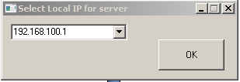

Figure 2

* Adjust the magnification value by the microscope game pad. 5000X is recommended for the CLEM procedure if your region of interest is not very large. Adjust eucentric height before collection region setting. The region will be defined as a rectangle using the start point and the end point. So first move the stage by the joystick in the microscope game pad to the start point and click “get” in the Start Point panel in the em\_picker software interface. Then move the stage to the end point and click “get” in the End Point panel in the em\_picker software interface. The coordinates will be imported (Figure 3).

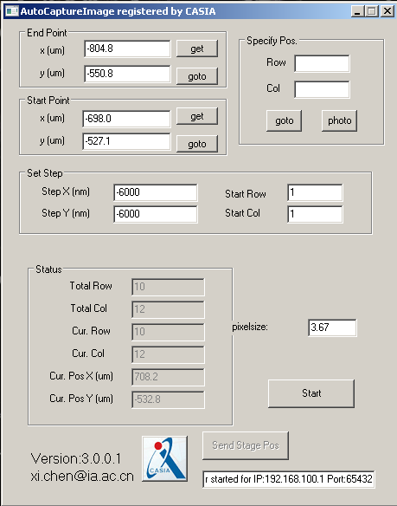

Figure 3

* Set step according to your magnification value. The setup should be about 85% of your total picture size because overlap area is necessary for montaging. If magnification value is 5000X (pixel size is 3.67 nm), the step can be set as 6000.Plus or minus before the step value depends on the coordinates of the start point and end point you select. In the example shown in Figure 3, the step should be --6000, -6000. After setting the region, click “goto” in the start point column to move the stage to the start point. Click “autosave” in TIA software and set the destination folder for the image sequence storage on computer A. By this way, the images can be autosaved once they are acquired by em\_picker. At last click “Start” in em\_picker to start collecting EM images. The Status panel shows the information during automatic collection. Just wait till all the images are collected.
  1. EM image splicing, FLM/EM correlation and EM navigation by the Mosaic software
* Transfer the autosaved EM images (\*.emi) to \*.jpg files by TIA in a folder named “jpeg”. Open the Mosaic software on computer B by double clicking hsMosiac.exe. Select “File” → “new library”. In the “Create Library” window (Figure 4), fill in the “Library Name” (e.g. EM), select the destination folder for the library file (\*. imgdb) and click “Create”. Then there will be your new library “EM” appeared on the left-side panel “Layer List”.
* 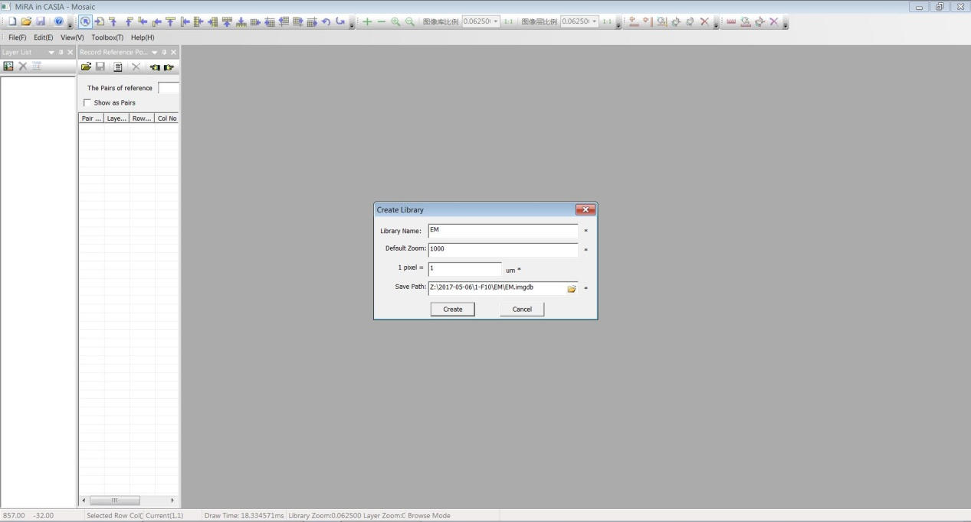

Figure 4

* Then select “Toolbox” → “EM Stage Navigation”. In the “EM Stage Navigation” window, enter the IP address of computer A as you select in the previous step. Then click “Connect EM” button. Select “Original Image Folder” where you storage transferred jpg files in “jpeg” folder. Copy the image prefix in “Image Prefix” and fill in “Start number” from the first autosaved image. In our example, the first image is named 19.08.36 CCD Acquire\_0001.jpg. So the image prefix is 19.08.36 CCD Acquire\_, and “Start Number” is 0001. After all these, click “Send stage Pos” in the em\_picker software to send the collected image coordinate information from computer A to the Mosaic software in computer B. Click “Transfer”. The raw image sequence with overlap area is imported in the Mosaic software (Figure 5).

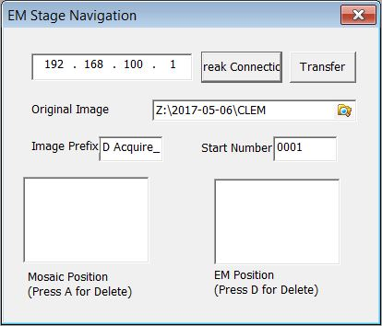

Figure 5

* After importing the EM image sequence, montage the images into a whole EM navigation map. Double click EM layer in the Layer List to display all the EM images. Measure the displacement of the same spot in the overlap area of two neighboring images. Click C:\Users\Sun\AppData\Local\Temp\1536840347(1).png (Single image) button, left click one spot in one image, and drag the end of yellow line onto the same spot of the image on the left. Check the horizontal displacement in the bottom line. Then left click one spot in one image, and drag the end of yellow line onto the same spot in the image above. Check the vertical displacement in the bottom line (Figure 6). Select “Toolbox ”→“Image Mosaic 2”. In the “Calculate Mosaic Index 2” window, fill in the horizontal displacement and the vertical displacement. Then click “Start” button to montage the EM images (Figure 7).

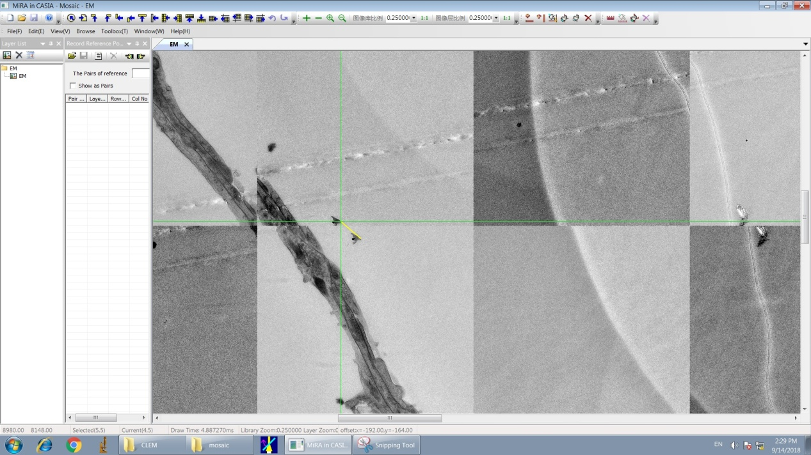

Figure 6

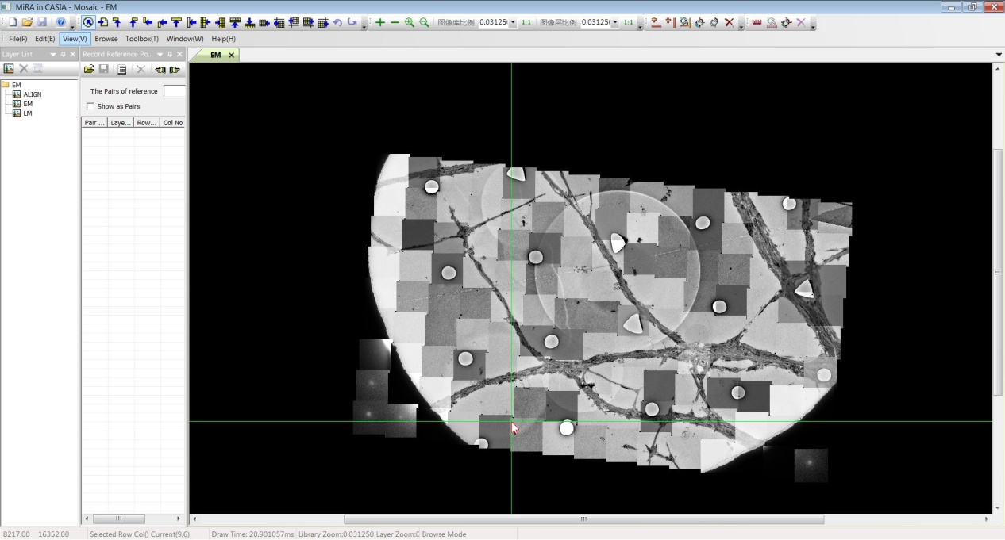

Figure 7

* After montaging the EM image, import the fluorescent image (\*.jpg) of the same sample taken before EM imaging into the Mosaic software by copy it to a newly-founded folder (e.g. named LM). Adjust the orientation of the FLM image, so that it is similar to the orientation of the EM navigation map. Rename the fluorescent image as 1\_1.jpg. Right click the library “EM” in the Layer List of the Mosaic software interface. Select “Create layer”. In the “Create Layer” window (Figure 8), fill in the “Layer name” (e.g. LM), select “Create Index File Automatically”, and fill in the “Index File” and “Image Folder” of the index file path and fluorescent image path. Then click “Create”. Double Click “LM” in the Layer List so that the FLM will appear in the Mosaic software interface. Drag the title bar of LM image towards the center of the software. Then the EM navigation map and FLM image will be displayed in two columns (Figure 9).

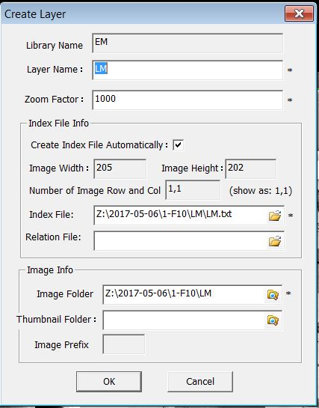

Figure 8

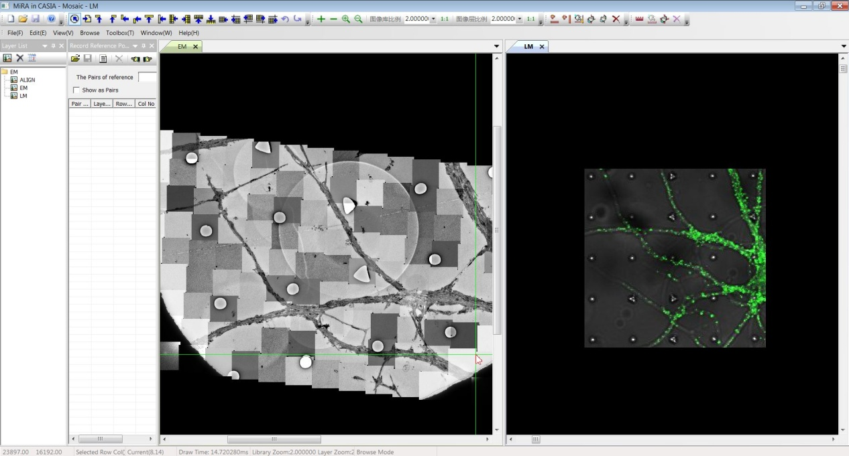

Figure 9

* Select “Toolbox” → “Record Reference Points”. In the “Record Reference Points” window, click the”” button . At this time, select “The Pairs of reference” 1. Press shift and left click the same spot (e.g. the same circle center in our PDMS design) in both EM navigation map and FLM image respectively. Then the two spots appear with their coordinates in the “Record Reference Points” window as group 1. Click the ”” button to select new reference spot groups. Select 4-6 groups relatively evenly distributed in the image. Click “” button and save it as “align.txt” (Figure 10).

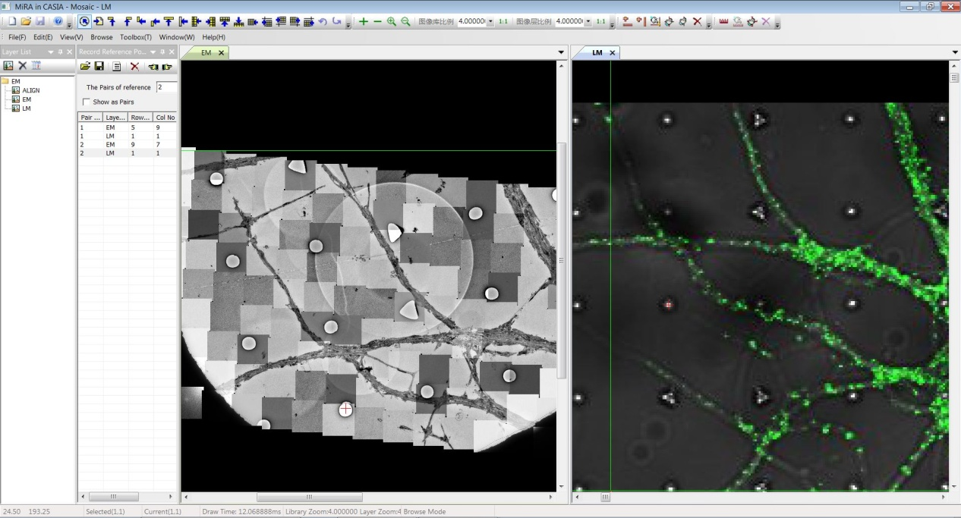

Figure 10

* Select “Toolbox” → “Image Fusion”. In the “Layer alignment and Fusion” window (Figure 11), select LM for “Layer for Bright Field” and “EM” for “Layer for EM”. Select align.txt in “File for Reference”. Set a destination folder for the aligned FLM image named “ALIGN”. Click “Align”. Right click “EM” in the Layer List and select” Create Layer”. In the Create Layer” window, fill in the “Layer name” (e.g. ALIGN). Do not select “Create Index File Automatically” and select “index.txt” in the rename folder under your previous founded jpg folder as the “Index File”. Fill in the “Image Folder” as the “ALIGN” folder. Then click “Create”. A new layer named “ALIGN” will appear in the “Layer List” panel. Close the LM image by clicking “X” in the tile bar. Double click “Aligned” in the Layer List and the aligned image will appear in the Mosaic software interface. Drag the title bar of aligned image towards the center of the software. Then the EM navigation map and aligned image will be displayed in two columns (Figure 12)

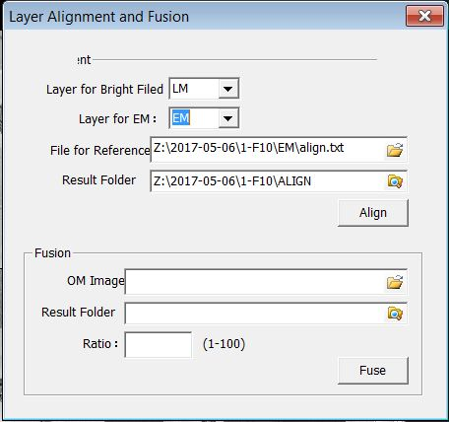

Figure 11

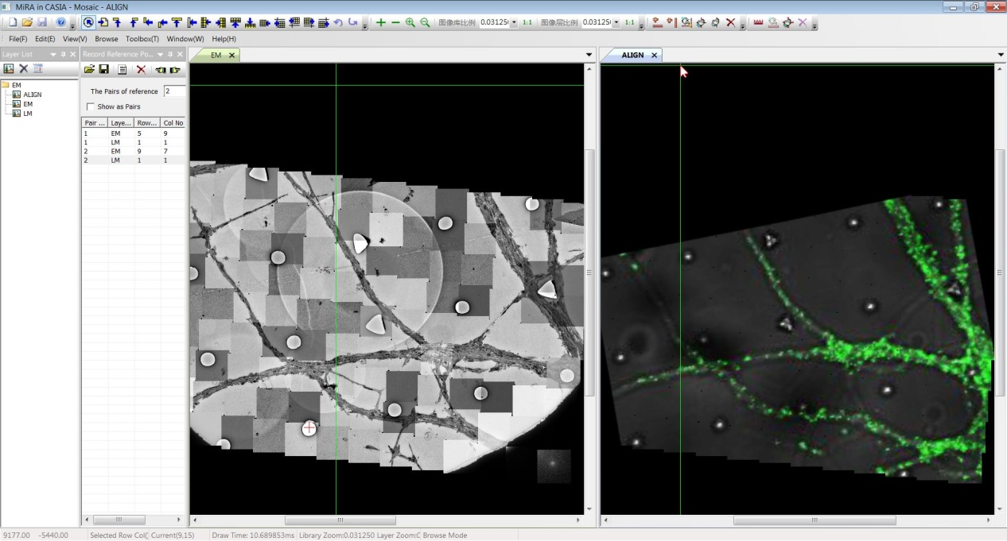

Figure 12

* Right click the EM image and select “Scroll Windows Simultaneously”. Two mouse arrows will point to the corresponding spots in the EM navigation map and aligned FLM image at the same time. Then select the fluorescent punctum by right clicking it. Select “Move Stage to Position” to move the stage to the position of the fluorescent punctum. Record the positions of fluorescent puncta in the TUI for further imaging or electron tomography.